Solution Requirements

Functional Requirements
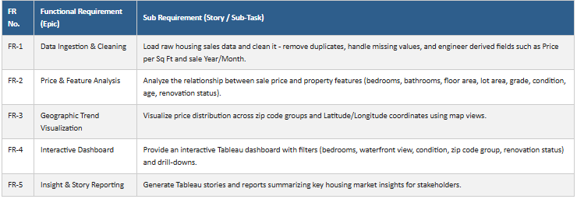

Non-Functional Requirements
